**CLASS ATTENDANCE APPLICATION**

**Abstract**

Replacing manual tasks of attendance taking with a comprehensive application can save a lot of precious teaching time. Our AI powered face recognition solution which uses Computer Vision and Machine Learning algorithms to mark the attendance of the employees or students of the organisation. This app is a really convenient choice to quickly and easily track a student’s attendance or their participation in any given event, program or classes. Following is the working of the application proposed-

Different institutes will have their unique logins to the application. Initially, an institute will upload its students identification details like name, roll number, photos etc. Then the model will be trained for the institute. Later depending on the class or event description, the corresponding attendance is taken by the system. The system will work on face recognition where each student in the class will be photographed and their details will be stored in a server. The teacher can then record the attendance by just clicking some pictures of the classroom. The system will recognize the faces and verify the presence or absence of each student. Thereby attendance reports can be generated easily.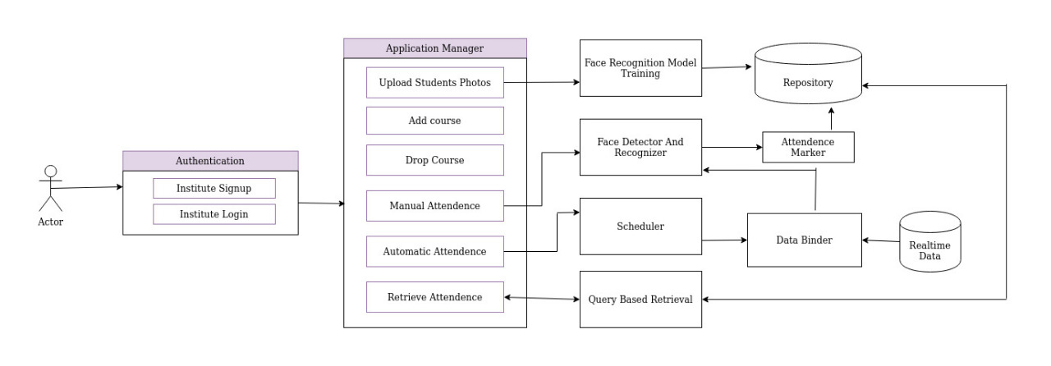

*Figure 1: Functional Overview Diagram*